Vermont Student Choreographer Scholarship Application

The mission of the Vermont State Dance Festival is to provide a non-competitive event that is open to various levels and abilities of dance technique, offers collaboration and cooperation amongst students, teachers, and professionals, and enhances a positive learning environment for all who share the love of dance education and performance.

A new addition to the 18th Annual VT State Dance Festival will be the Vermont Student Choreographer Scholarship!

The Vermont Student Choreographer Scholarship is an opportunity for students from studio or high school dance programs to showcase their passion for the art of dance and talents in dance performance through choreography. Students applying for this scholarship will create and perform their own original work based on an artistic statement that is supported through proper anatomical and technical dance skill as well as the use of the elements of dance. Choreographies submitted will be reviewed and scored by a panel of dance professionals and the winning choreography will receive a monetary scholarship presented at the annual Vermont State Dance Festival. The winner will receive his/her award and perform his/her work at the Vermont State Dance Festival for participants and guests.

Criteria for submission:
- Student must a high school junior or senior
- Student must be enrolled in a high school or studio dance program
- Student applying must attend this year’s Vermont State Dance Festival
- Work submitted must be created by the student
- Choreography will be between 1:00-1:30 min in length
- Choreography will be based on an artistic statement
- Choreography may be based in any dance style/genre
- Student will email/share video of his/her work with completed application by due date to Rebecca McGregor (no late submissions will be accepted)

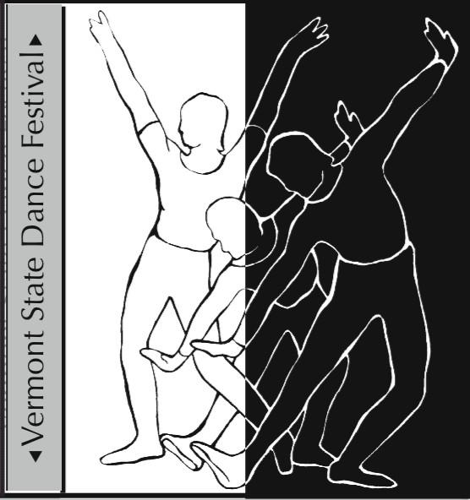
Application Form:

Student Choreographer Name: ___________________________________________________________

School/Studio of Dance: ___________________________________________________________
Student’s Year in School: ____________

Student Choreographer Home Mailing Address:
______________________________________
______________________________________
______________________________________
Student Choreographer Email: ___________________________________________________________
Student Choreographer Phone Number: ____________________________________________________

Title of Choreography Submitted: ____________________________________________________
Choreographer’s Artistic Statement:
_________________________________________________________________________________________________________________________________________________________________________________________________________________________________________________________________________________________________________________________________________________________________________________________________________________________________________
Describe how the elements of dance were used to show your artistic statement:
_________________________________________________________________________________________________________________________________________________________________________________________________________________________________________________________________________________________________________________________________________________________________________________________________________________________________________
Music/Artist for Choreography: ____________________________________________________
Length of Choreography: _______
Video and completed application form must be submitted by midnight on Friday, October 2nd, 2020.

